EXPT 5 (b) Modelling and Simulation of a 4-Layer IoE Architecture (Perception–Network–Middleware–Application) using Node-RED, MQTT and a Cloud Dashboard
Objectives
- To model the four-layer IoE architecture using Node-RED.
- To simulate sensor data using Inject nodes.
- To transmit and process data using MQTT and Function nodes.
- To visualize sensor readings on a dashboard.
- To verify data flow across all four IoE layers.
Software Required
- Node-RED
- MQTT broker (Mosquitto or Node-RED MQTT nodes)
- Node-RED Dashboard
Procedure
- Create a new flow in Node-RED.
- Use an Inject node to simulate sensor readings.
- Represent the Perception layer using simulated sensor data.
- Use MQTT nodes to transmit data through the Network layer.
- Process and validate messages using a Function node in the Middleware layer.
- Display sensor readings using dashboard widgets in the Application layer.
- Verify the complete data flow using Debug nodes and dashboard values.

Output(1)
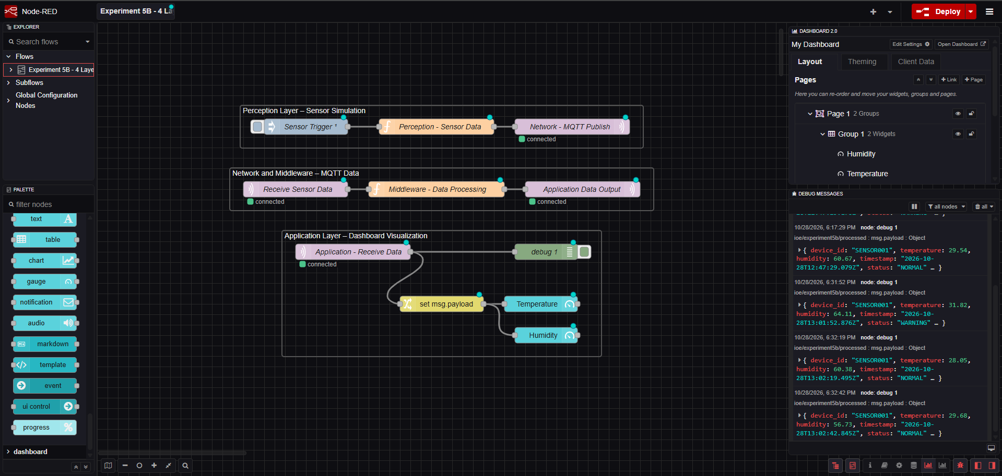
(2)

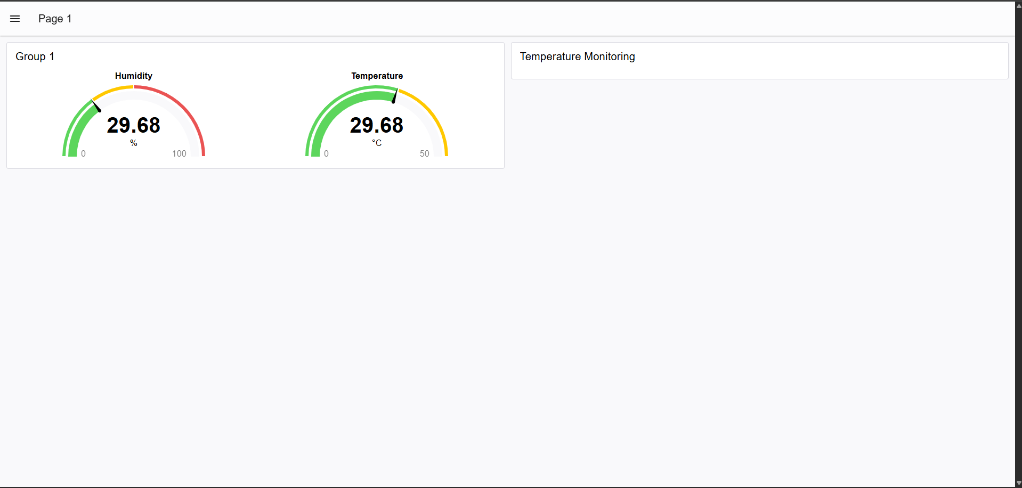

Output Table
S.No. | Layer | Simulated Function | Expected Output
1 | Perception | Generate sensor data | Sensor values
2 | Network | Transmit using MQTT | Received messages
3 | Middleware | Process data | Validated values
4 | Application | Dashboard visualization | Displayed readings

Result
The four-layer IoE architecture was simulated in Node-RED using MQTT, and the data flow from sensor input to dashboard visualization was verified.

